**Lab B week 11**

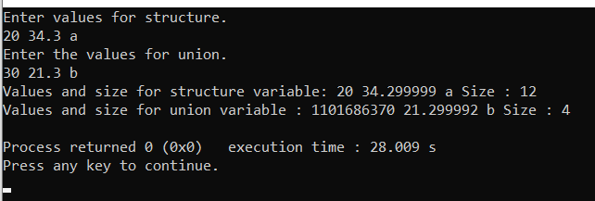Q1. #include <stdio.h>

struct abc

{

int a;

float b;

char d;

}x;

union {

int a;

float b;

char d;

}y;

int main()

{

printf("Enter values for structure.\n");

scanf("%d%f %c",&x.a,&x.b,&x.d);

printf("Enter the values for union.\n");

scanf("%d%f %c",&y.a,&y.b,&y.d);

printf("Values and size for structure variable: %d %f %c Size : %d\n",x.a,x.b,x.d,sizeof(x));

printf("Values and size for union variable : %d %f %c Size : %d\n",y.a,y.b,y.d,sizeof(y));

}

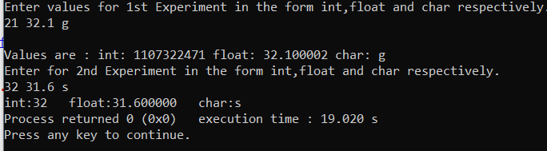Q2. #include <stdio.h>

union abc{

int a;

float b;

char d;

}x,y;

int main()

{

printf("Enter values for 1st Experiment in the form int,float and char respectively.\n");

scanf("%d%f %c",&x.a,&x.b,&x.d);

printf("\nValues are : int: %d float: %f char: %c",x.a,x.b,x.d);

printf("\nEnter for 2nd Experiment in the form int,float and char respectively.\n");

scanf("%d",&y.a);

printf("int:%d ",y.a);

scanf("%f",&y.b);

printf("float:%f ",y.b);

scanf(" %c",&y.d);

printf("char:%c ",y.d);

return 0;

}

Q3. #include <stdio.h>

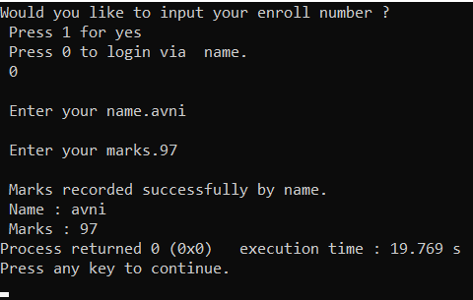union abc{

char name[20];

int enroll;

}x;

int main()

{

int n;int marks;

printf("Would you like to input your enroll number ? \n Press 1 for yes \n Press 0 to login via name.\n ");

scanf("%d",&n);

fflush(stdin);

switch(n)

{

case 0:

printf("\n Enter your name.");

gets(x.name);

printf("\n Enter your marks.");

scanf("%d",&marks);

printf("\n Marks recorded successfully by name. \n Name : %s \n Marks : %d",x.name,marks);

break;

case 1:

printf("\n Enter your Enrollment Number.");

scanf("%d",&x.enroll);

printf("\n Enter your marks.");

scanf("%d",&marks);

printf("\n Marks recorded successfully by Enrollment no. \n Enroll no. : %d \n Marks : %d",x.enroll,marks);

break;

default:

printf("\n Wrong choice.");

}

return 0;

}

Q4. #include <stdio.h>

#include <stdlib.h>

struct abc{

int id;

char name[20];

int age;

int salary;

}x[5];

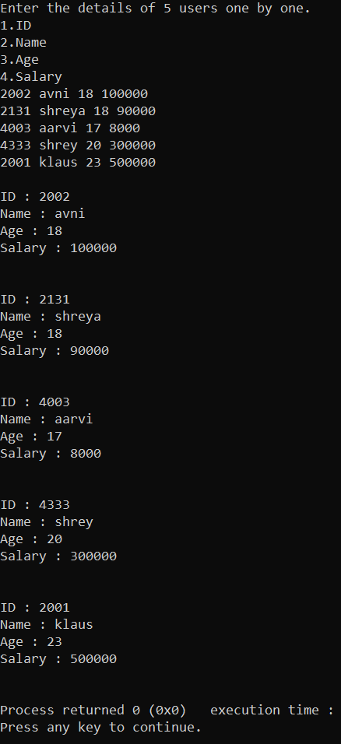int main()

{

printf("Enter the details of 5 users one by one.\n1.ID \n2.Name \n3.Age \n4.Salary\n");

for(int i=0;i<5;i++)

scanf("%d%s%d%d",&x[i].id,&x[i].name,&x[i].age,&x[i].salary);

for(int i=0;i<5;i++)

printf("\nID : %d \nName : %s \nAge : %d \nSalary : %d \n\n",x[i].id,x[i].name,x[i].age,x[i].salary);

}

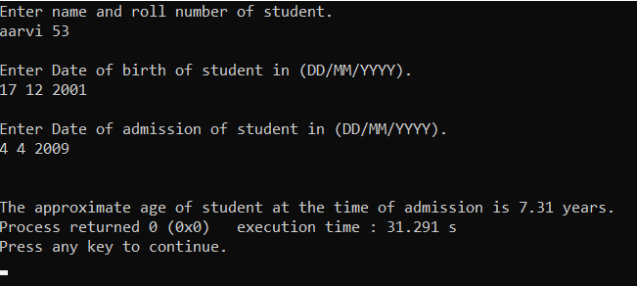Q5. #include <stdio.h>

#include <stdlib.h>

struct student{

char name[20];

int roll;

int dby;

int dbm;

int dbd;

int day;

int dam;

int dad;

}x;

int main()

{

printf("Enter name and roll number of student.\n");

scanf("%s%d",&x.name,&x.roll);

printf("\nEnter Date of birth of student in (DD/MM/YYYY).\n");

scanf("%d%d%d",&x.dbd,&x.dbm,&x.dby);

printf("\nEnter Date of admission of student in (DD/MM/YYYY).\n");

scanf("%d%d%d",&x.dad,&x.dam,&x.day);

float diff=(x.day*365+x.dam*30+x.dad)-(x.dby*365+x.dbm*30+x.dbd);

printf("\n\nThe approximate age of student at the time of admission is %.2f years.",diff/365);

}